UCR Kebabs By Dale smallwood, Cameron Day, Mohammed haseeb

Dale Smallwood Dale smallwood: 130089872

Dale Smallwood Mohammed haseeb 160002149

Dale Smallwood cameron day: 160138312

Contents

Table of Figures 2

Introduction 3

Acknowledgements 4

Project Goals 5

Business opportunity 6

Design and wireframes 7

Logo 10

Did we hit our project goals? 12

UI, colour scheme and Heat maps for the site 12

Heatmaps 14

Creating a working website for UCR Kebabs 15

The website to have a shopping cart feature 16

Create a functioning database with different features which log information 16

To create a simulated network with high security 17

Network simulation 18

Network Simulation 18

OSPF 18

Network Trunking 19

Database 19

Test log for the Website 20

Test log for the network 21

21

Conclusion 22

Glossary 23

Bibliography 24

# Table of Figures

Figure 1 - Initial Idea 7

Figure 2 - Final Wireframe 8

Figure 3 menu page Wireframe 9

Figure 4 - UCR Kebabs Concept Logo 1 10

Figure 5 - UCR Kebabs Concept Logo 2 10

Figure 6 - UCR Kebabs Concept Logo 3 10

Figure 7 - UCR Kebabs Logo Square 11

Figure 8 - UCR Kebabs Logo Circle 11

Figure 9 (Sessions College, 2022) 12

Figure 10 Before the colour scheme 13

Figure 11 after the colour scheme 13

Figure 12 high-quality images 14

Figure 13 Heatmap admin 14

Figure 14 Home heat map 15

Figure 15 database login 16

Figure 16 database for the website 17

Figure 17 database for the website 18

Figure 18 - Network Simulation Concept 19

# Introduction

Inside this document, we will be discussing the project that has been created which is a website for a store known as “UCR kebabs” the store has a website with products and a shopping cart created for it, which interlinks into a database that collects records and information on customers this will be. Hosted on a simulated network with high security, The goal of this document was to record the progress of the group and evaluate what was created together as a team multiple daily meetings had occurred to work on different tasks within the project which led to UCR kebabs being created.

# Acknowledgements

*Dale Smallwood for creating the website and database for UCR kebabs and writing the HTML, CSS, PHP and Heatmaps as well as editing the document; Cameron day who created the Network simulation and logo for UCR Kebabs and Mohammed Haseeb who had created the initial designs, wireframes, Colour scheme and also edited the document for UCR kebabs.*

# Project Goals

* **To design a website for UCR Kebabs**
* **Ui colour scheme**
* **Create a working website for UCR Kebabs**
* **The website to have a shopping cart function**
* **Create a functioning database which logs information such as usernames, emails, passwords, number of products**
* **To create a simulated network with high security**

# Business opportunity

In 2022 it is very difficult to run a business without a social presence which allows customers to find your establishment or contact details as the author (Marketing insider group, 2021) mentions’ “*It doesn’t matter if you run a small local shop or a big national company. Social media is more than just a trend. It is an essential piece of your business marketing strategy*.” for a kebab shop with the ability to order online and pick up in-store would save a lot of time as people cannot always have access to a phone or the line may be busy due to orders taking place.

# Design and wireframes

Wireframes are vital as they show the design of a specific web page such as the home page. This is reinforced with (Barnard, n.d.) quote. “Wireframes are unique in that they help you get to a design solution quickly and make it easy to communicate the solution to different kinds of people” As seen in Figure1 these are the initial designs for the website UCR kebabs was the first implementation of the design thought out. Upon a group decision, we had all played out our ideas of what we wanted to see from the final product. Further changes were made due to time constraints or disagreements on certain features and looks. Figure2 was a good first design for the website but lacked a lot of things that the project goals needed, and this was. The shopping cart system and log in so needed to be worked upon in the final version to allow the wireframes to help craft the website. After much discussion and changes the final wireframes were created as seen in Figure3, these designs were agreed upon after revisiting our initial designs and comparing them with our project goal. The wireframes now contain the features that were lacking from our project goals such as the shopping cart and the login system these were added which completes our view of the website and meets the goals.

Figure 1 - Initial Idea

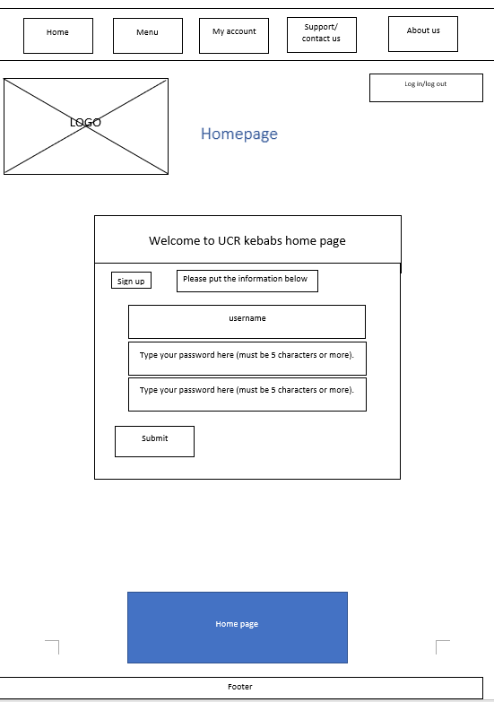

Figure - Final Wireframe

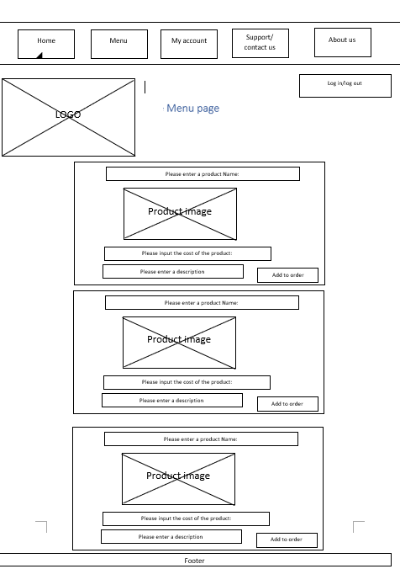

Figure menu page Wireframe

# Logo

A company must have a high-quality logo which advertises its business correctly. With this in mind, the logo took into consideration the company’s purpose which is making Kebabs. This is shown using (Vistaprint, n.d.) quote “Most businesses will have a logo of sorts, but having a well-designed, memorable logo was found to encourage over a quarter of shoppers (27 per cent) to buy from a small business.” (Vistaprint, n.d.). The project company name which is UCR Kebabs stated that the logo will be based on the name. The client requested that the colour scheme for the logo needs to be White and Orange for a brighter look and to contain only royalty-free images. The logo consists of the company’s name with a skewer going through the Kebab which adds some creativity to the logo. A royalty-free image was used of Kebab meat to be placed of the “K, B, B” which gives it more of a professional look.



Figure - UCR Kebabs Concept Logo 1

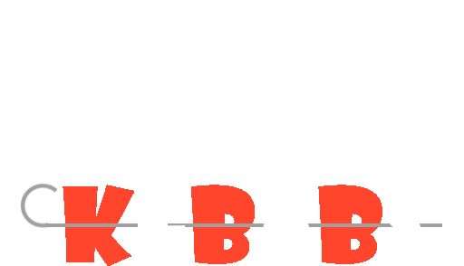

Figure - UCR Kebabs Concept Logo 2



Figure - UCR Kebabs Concept Logo 3

The concepts were presented However, mutually it was decided on the figure 8 design. This is because the writing for the word “UCR” is clearer as it stands out more the square design flowed better with the rest of the website’s design and colour scheme. The concepts were presented to the group in which they picked the figure8 option for the company.



Figure - UCR Kebabs Logo Square



Figure - UCR Kebabs Logo Circle

# Did we hit our project goals?

## UI, colour scheme and Heat maps for the site

For the website, a colour scheme was decided for UCR kebabs to help people feel comfortable on the site whilst browsing so a group decision of analogous as shown in Figure9 colour scheme was decided upon the author (Coral, 2022) explains that “Perhaps because of the connection with nature, rooms featuring analogous colour palettes often have a serene, harmonious feel.” This statement fits our criteria when searching for a calming colour scheme, so this was implemented on the site and the website had turned out better than anticipated as seen in Figure10 which is before the colour scheme was applied and Figure11 which is what the final version looks like. So, we all agreed that the Ui had been achieved as a project goal.

Another factor was to use high-quality images to capture the user’s attention for the menu page according to (Laja, 2020) mentions “Image quality is a significant factor in drawing attention.” So high-quality royalty images were used on our menu page as shown in Figure12 as the images are complemented with the UI.

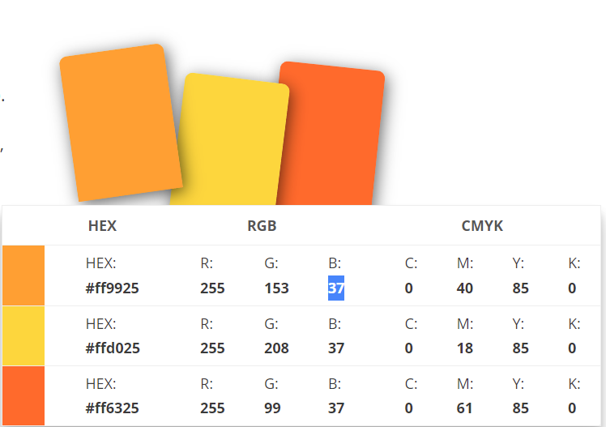

Figure (Sessions College, 2022)

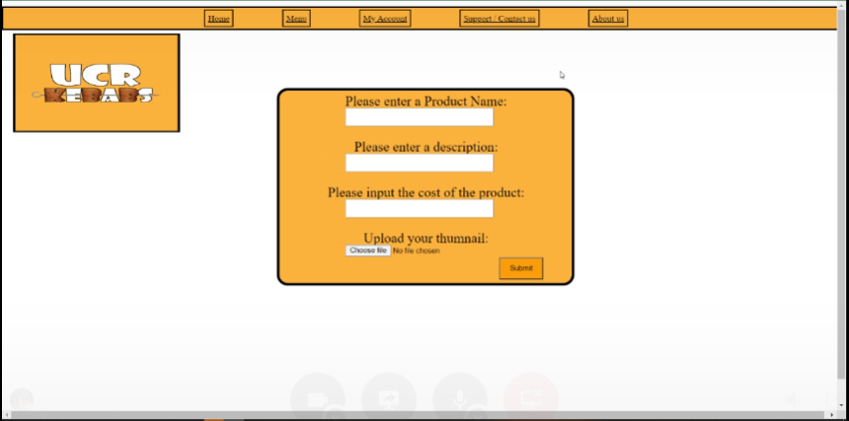

Figure Before the colour scheme

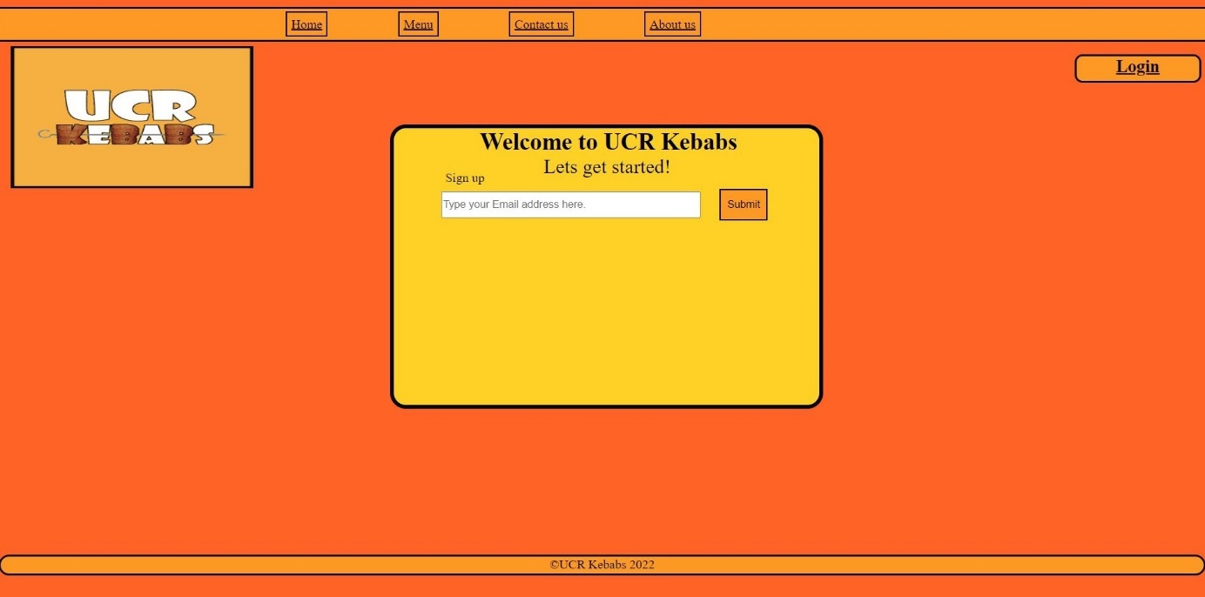

Figure after the colour scheme

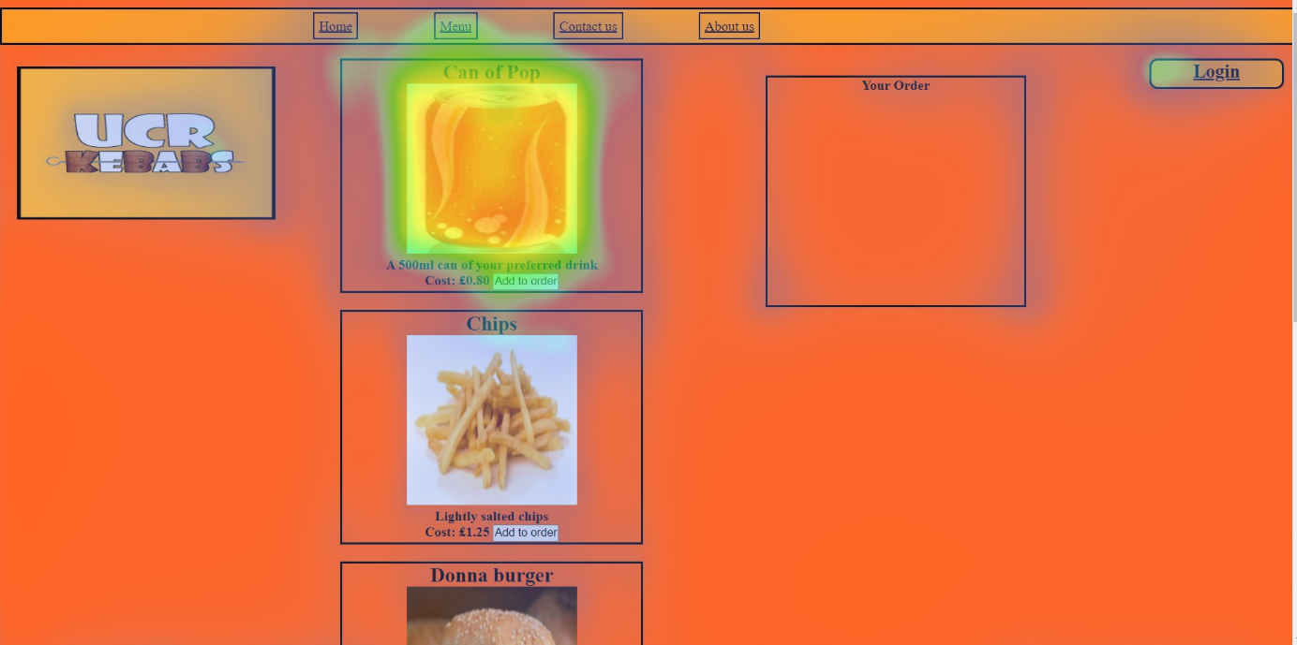

Figure high-quality images

## Heatmaps

Heat map tests were done on the website to track where people focus their attention when initially landing upon each page for the first time using our analogous colour scheme our goal was to focus the attention on specific areas of the page such as text boxes and login forums. By using a brighter colour on them sections this is evident in Figuire13 and also in Figuire14 Where you can see the majority of the lit areas were exactly where the content was displayed so text boxes and user forums, so the UI was a success.

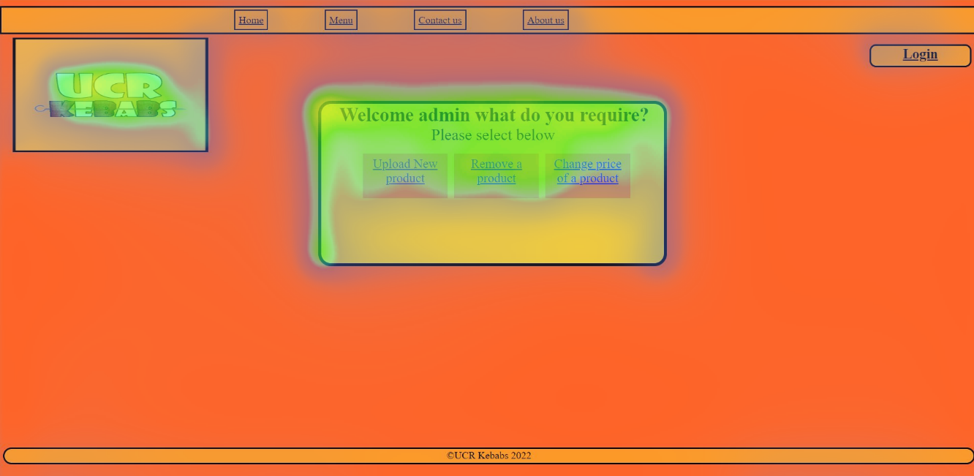

Figure Heatmap admin

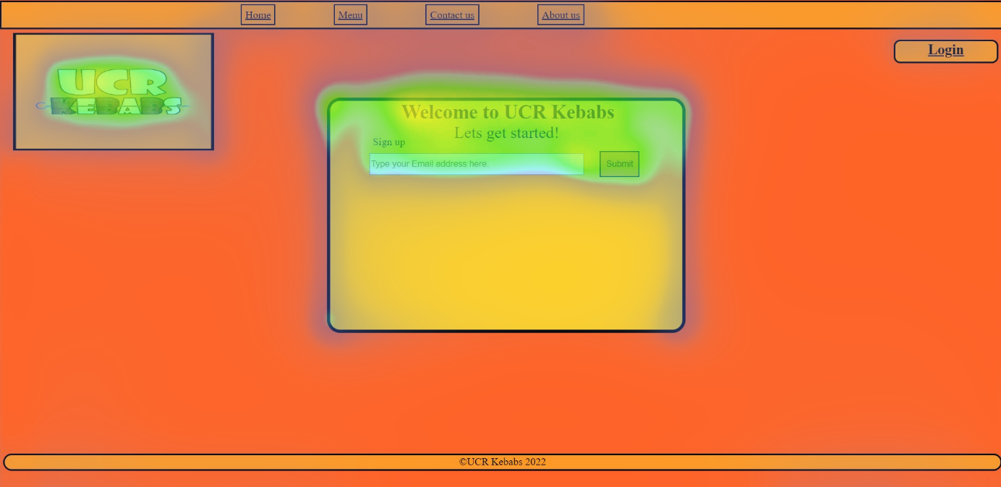

Figure Home heat map

## Creating a working website for UCR Kebabs

The website was created for UCR Kebabs which was a success with no errors that have been found just yet as a test log was created on the website which had tested the features and pages and buttons the test log ensured that the website had no minimal errors, so the functionality of the website was met with the goal. Whereas it is working there are some errors with the website that need to be addressed such as a bug with the shopping cart feature and not being able to upload new products through the admin page. If given more time these could be looked at and fixed due to time constraints they were left in the final version of the build. But overall, the website is working as intended and functions as it allows users to log in with a username and password.

## The website to have a shopping cart feature

The shopping cart feature was added to the website of UCR Kebabs to ensure a method for customers to order more than one item online and be able to pick it up instore (Umesh, 2022) mentions “*Shopping carts can make or break the deal between you and your online customers.”* (Umesh, 2022). The shopping cart was a key feature that had to be met as it is a very common feature that most other online stores have. The goal was not met as the products would not go into the shopping cart after many attempts many hours were spent on bug fixes and research, but the shopping cart feature could not be implemented successfully, however, the products are still available to view. As a project goal, this was not met however if given more time this could be implemented in the future.

## 

## Create a functioning database with different features **which log information**

As seen from Figure15 this project goal was achieved as when a user goes to sign in or sign up with an email address or password the database logs the data into it including usernames, passwords, number of products, and user levels. This is a project goal that was reached as the database functions and meets the requirements set out earlier in its development.

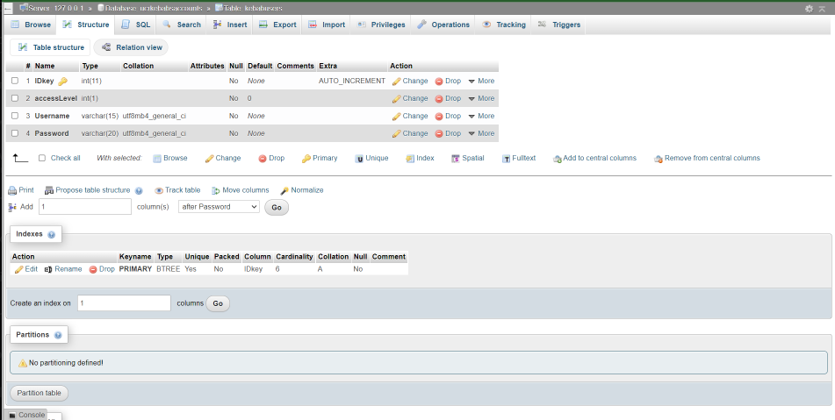

Figure 15 database login

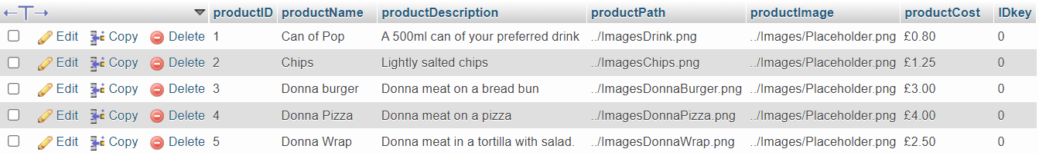

Figure 16 database for the website

## To create a simulated network with high security

As can be seen in Figure16 The network simulation had been completed which showcases a simulation of how the company will be running the network on the network has line console passwords and encryption so not just any hacker can plug in a cable and gain access to the database which has been created for the website UCR kebabs.

The network simulation was a success as it showcases an online database rather than a paperback and also offers encryption to provide a level of security that isn’t as exposed as other methods. This will help the business stay secure as it proved the most basic level of mitigation from attacks.

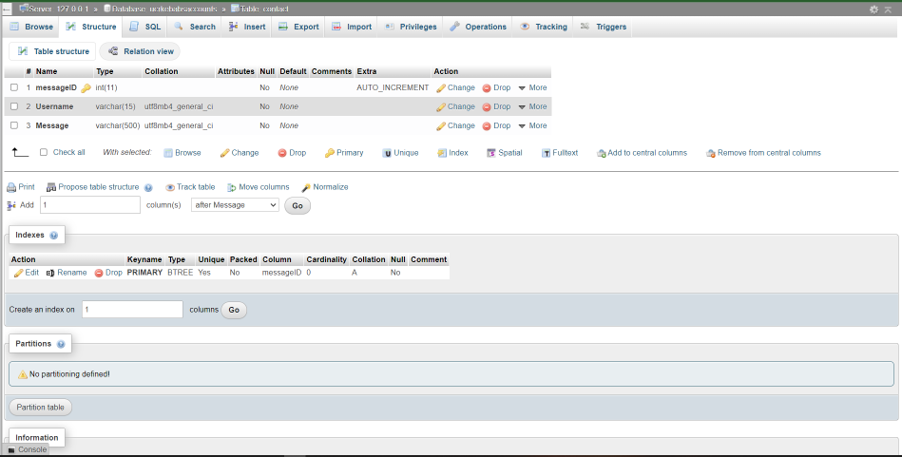

Figure database for the website

# Network simulation

The client requested that a network be installed into the business. They have specified that the website and database be connected to the network to take online orders and orders that the FOHS place and that the network has the facility to be developed further should the business choose to expand.

The client would like the network to be outfitted with the latest security protocols and strategies to protect the business while maintaining a fast and stable connection.

## Network Simulation

A network simulation was created in Packet Tracer which will be implemented into the business once the client agrees with the design. The network which is Figure18 will utilise the following protocols.

### OSPF

OSPF will be installed onto the router to protect and privatise the network. This will also connect the company’s router to the ISP, creating an encrypted bridge between both networks. “Routing protocol like OSPF is that the complete knowledge of topology allows routers to calculate routes that satisfy particular criteria. (Metaswitch, n.d.)

### Network Trunking

Network Trunking connects multiple switches to enable the network to easily communicate across multiple sections. This allows for less congestion on the network, This also allows for the company to expand in the future, as Trunking enables multiple hosts to be connected to the same network.

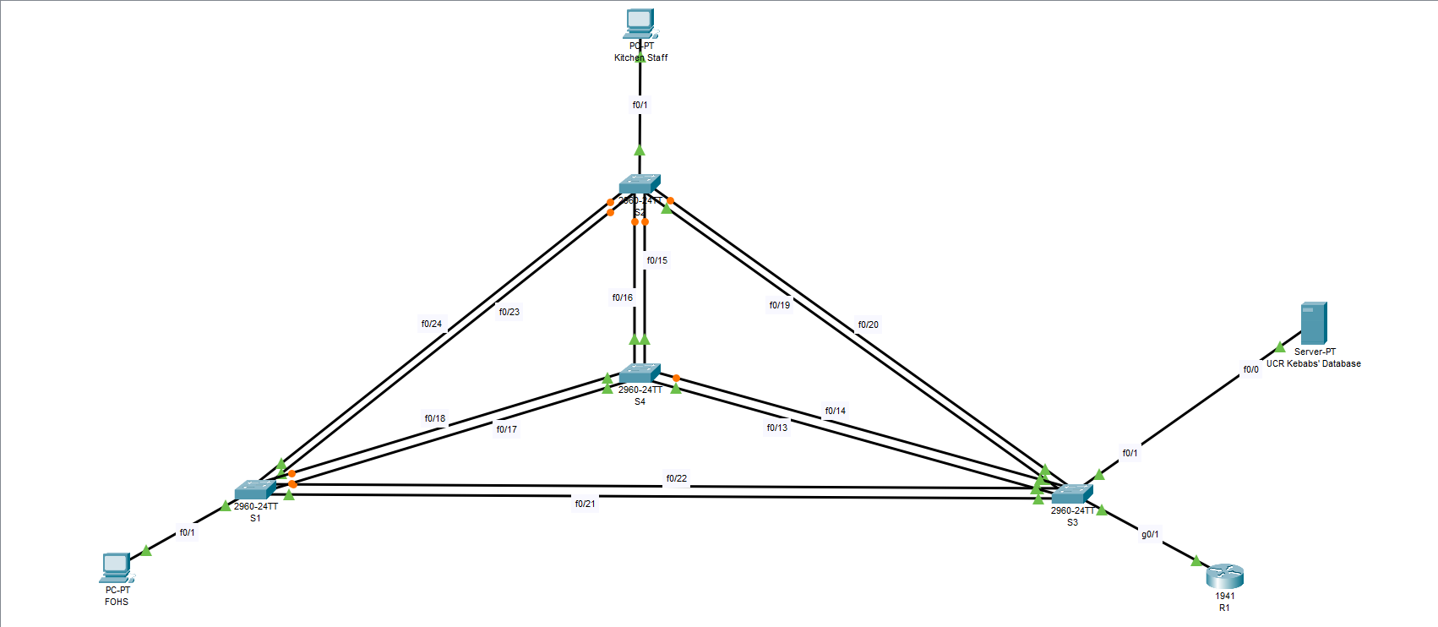

Figure - Network Simulation Concept

The database will also be integrated directly into the network so all information regarding orders and payments can be logged. The concept was presented to the group in which the group agreed that it was to the specification of UCR kebabs.

# Database

In 2022 for a business to do well, a network is needed as it’s almost vital as it makes it easier for both the business and customer in that it helps tasks to be done quickly and having a digital database will aid it in the most helpful way possible as according to (TeachICT, 2022) it has a number of benefits such as *“Can hold a vast amount of data over the paper-based database” “Difficult to search for a specific criterion; every record would have to be manually looked at. Compared to computerised where you Can easily search for a specific criterion e.g., "all of the people who live in Warwick"* The threat of hackers is also prevalent and security is needed in the network encryption was added so that the intruders would find it hard to pull data from the routers as all the passwords are covered up the commands for this line were as follows: “enable” “conf t” “enable secret my password” “exit” “write”.

# Test log for the Website

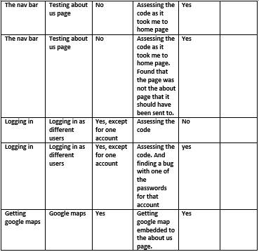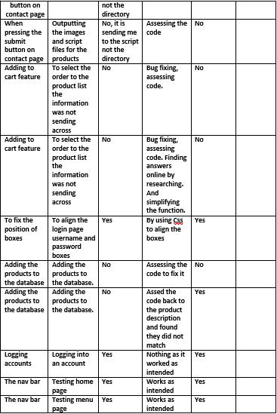

# Test log for the network

# 

# Conclusion

Most of the project goals had been met except for one goal, however, If the opportunity had arisen to work together again programs such as team viewer or atom teams would be used to simultaneously be working on a project to see the vision of the project transform clearer without any miscommunication.

(Phill & Rebecca maguire, 2014) mentions “A wide range of benefits have been reported, 1 such as improved quality of code, decreased time to complete, improved understanding of the programming process, enhanced communication skills”

# Glossary

FOHS – Front of House Staff

ISP – Internet Service Provider

# Bibliography

Barnard, L. (n.d.). *Why Wireframes Are Still Relevant*. Retrieved from Balsamiq: https://balsamiq.com/learn/articles/wireframes-still-relevant/

Coral, N. (2022, April 04). *Understanding Analogous Colors*. Retrieved from The spruce: https://www.thespruce.com/understanding-analogous-colors-1973820

Laja, P. (2020, February 23). *10 Useful Findings Of How People View Websites*. Retrieved from CXL: https://cxl.com/blog/10-useful-findings-about-how-people-view-websites/#:~:text=The%20left%20side%20of%20the,20%25%20viewing%20the%20right%20half.

Marketing insider group. (2021, August 9). *Why Social Media Is Important for Business Marketing*. Retrieved from Marketing insider group: https://marketinginsidergroup.com/content-marketing/why-social-media-is-important-for-business-marketing/

Metaswitch. (n.d.). *What is Open Shortest Path First (OSPF)?* Retrieved from Metaswitch: https://www.metaswitch.com/knowledge-center/reference/what-is-open-shortest-path-first-ospf

Phill, m., & Rebecca Maguire, P. H. (2014). *Enhancing Collaborative Learning Using Pair.* Department of Computer Science, NUI Maynooth, AISHE-J. Retrieved 6 5, 2022, from https://ojs.aishe.org/index.php/aishe-j/article/view/141

Sessions College. (2022, 5 6). *Colour Calculator Results*. Retrieved from sessions.edu: https://www.sessions.edu/color-calculator-results/?colors=ff9925,ffd025,ff6325

teach it. (2022, March 19). *3. Computerised Vs paper-based databases*. Retrieved from Teach-CIT.com: https://www.teach-ict.com/ks3/year7/data_handling/miniweb/pg3.htm

Umesh, K. (2022, April 18). *What is a Shopping Cart & Why is it Important?* Retrieved from Techbullion: https://techbullion.com/what-is-a-shopping-cart-why-is-it-important/

Vistaprint. (n.d.). *Understanding Logos*. Retrieved from Vistaprint: https://www.vistaprint.co.uk/hub/understanding-logos?PCXTVATINCLUSIVE=&utm_id=2B06230702543290257184&coupon=&partner=google&ps_vtp=13243590707|126327517801||dsa-19959388920|c|1006691||g&ps_vtp2=g|||523681412550|||||&gclid=Cj0KCQjwpcOTBhCZARIsAEAYLuVLPs_1L